

ULTRASOUND IN DIAGNOSIS CORONAVIRUS

Student’s Name

CORONAVIRUS

Corona virus is a type of virus that causes diseases. The virus is found in animals and can be transmitted to humans and then between people by coming into contact with droplets of an infected person (Novel, 2020). The diseases caused by the virus range from the common cold to severe ones such as the Middle East respiratory syndrome (MERS) and severe acute respiratory syndrome (SARS).
Symptoms of Corona virus
The symptoms of corona virus disease include;
- Fever
- Cough
- Shortness of breath
- Breathing difficulties
- Muscle aches
- Sore throat
- Headache
- Diarrhea
- Loss of taste or smell

QUICK FACTS
- The virus spreads through respiratory droplets that are produced when an infected person sneezes or coughs.
- It can also be spread through close contact.
- Currently, there is no vaccine to prevent against the disease. The best way to stay safe is to take preventative actions such as washing hands and avoiding contact with infected people.

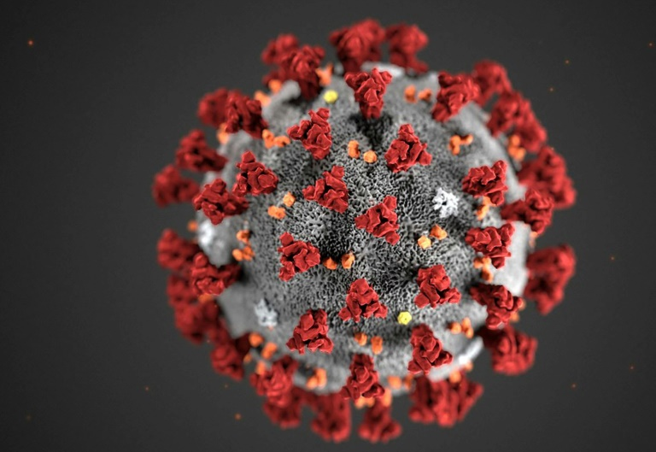
Coronavirus

Lung Ultrasound

Lung ultrasound entails critical ultrasound application, which links urgent diagnoses with curative decisions. Lung ultrasound relies on ten signs, namely.
- The bat sign also referred to as pleural line
- Lung sliding also is known as yielding seashore sign
- A-line
- The quad sign
- Sinusoid sign
- The factual and tissue-like sign
- B-line
- Lung rockets Abolished lung sliding
- Stratosphere sign
- Lung point
How is lung ultrasound currently being used in hospitals?
The use of lung ultrasound has grown to be a valuable tool used in critical care medicine. This is used in the diagnosis of abnormal conditions. Lung visualization often needs the use of 5mHztransducer fir transthoracic examination. However, its use is based on the protocol followed by the healthcare provider (Buonsenso et al., 2020). Amid the Covid-19 pandemic, lung ultrasound is being used to assess the level of lung involvement in patients with infections. Lung ultrasound is used to identify patients with corona virus disease (Huang et al., 2020).

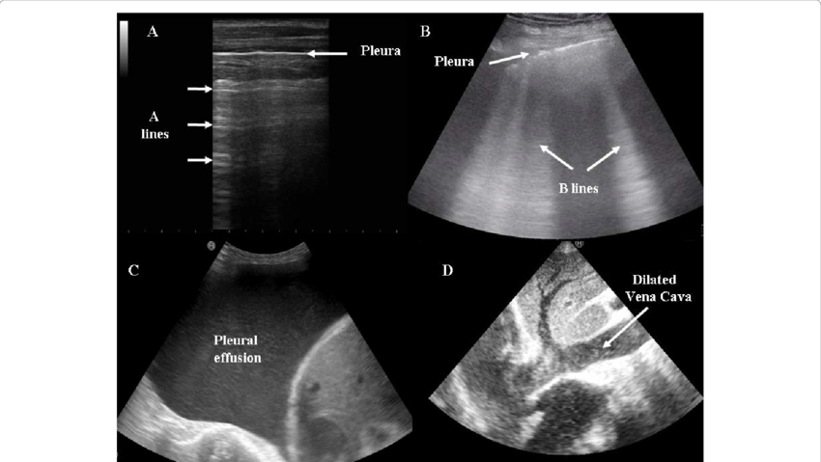
Lung ultrasound finding on a patient with Covid-19 disease

The finding of Covid-19 on Lung US scans

The use of lung ultrasound in cardiac units, critical care, and emergency departments was increasingly taking shape, and with the global corona virus pandemic, it has become popular in use. Lung ultrasound in patients with Covid-19 shows pleural thickening, multifocal B-lines, and sub pleural consolidation. These findings show that lung ultrasonography is effective in the workup of Covid-19 suspected patients (Peng et al., 2020). Covid-19 lung ultrasound findings may be non-specific, but they are at part with other respiratory diseases. Lung ultrasound provides critical and best data that complements chest radiography (Soldati et al., 2020).
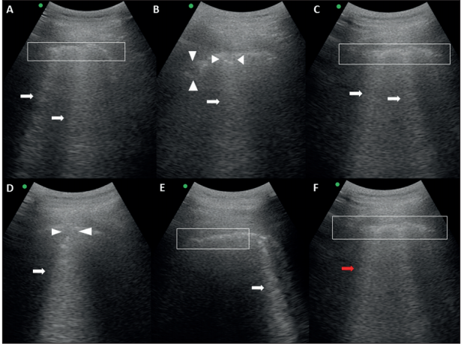
Patient with covid-19 lung ultrasound findings
Factors that may affect Covid-19 findings on Lung US scans
The factors include;
- Pulmonary embolism
- Pneumothorax
- Lung contusion
- Pulmonary fibrosis

Limitations of Lung Ultrasound

Lung ultrasound is conducted on patients in critical care and may often critical information on a patient’s lung status with various diagnostic and curative evidence. It, however, has its shortcomings. For instance, lung ultrasound allows for pleural-based masses to be assessed, therefore proportionally providing information with the tumor's dimension of contact being the chest walls (Chiumello et al., 2018). A small part of the tumor can be visible in instances when pleural abutting is minimal. The interposition of various parts often limits peripheral lesions' visibility.
Another significant limitation of lung ultrasound entails the existence of chest wall pathology.
When the tumor comes into contact with the heart limits TNB as a result of the lesion movement.

Comparing CT and US findings in Covid-19

As there are no vaccines and curative drugs of Covid-19, the disease must be detected at an early stage and subsequently isolated from the general population. CT imaging and US are more reliable to diagnose and evaluate Covid-19 (Poggiali et al., 2020). CT, an imaging tool is used to diagnose pneumonia, is easy to perform and relatively fast. The features of lung ultrasound, on the other hand, are often associates with comorbidities, the stage of the disease, and the severity of lung injuries.
The use of Lung Ultrasound in place of CT
Lung ultrasound (US) has proven to be an effective tool mainly in pneumonia diagnosis. Its accuracy is, however, limited to pneumonia. CT uses radiation, which can cause adverse health implications, which make the use of ultrasound imaging modality for abdominal, cardiovascular, and pelvic indications.

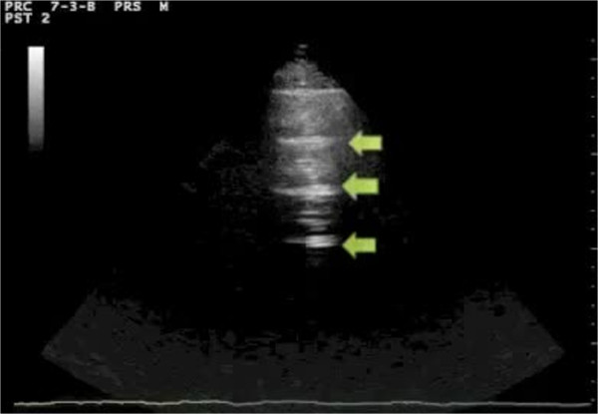
Sonographic appearance of a lung scan

Summary and Recommendations
Lung ultrasonography uses a tailored diagnostic and curative approach in taking care of critically ill patients. Lung ultrasound is critical and effective in the assessment and early detection of lung pathologies and plays an important role in management protocol. Preliminary studies indicate that lung ultrasound can be an effective tool in identifying and diagnosing Covid-19. Chest CT has always been considered as a modal and appropriate choice in estimating the lung damage, and they are not often available, therefore making lung ultrasound an effective tool to diagnose and assess patients. Lung ultrasonography is a valuable and non-invasive tool that can be used to diagnose and assess lung diseases. However, there is lack of proper protocols, guidelines and reference standards that may affect its application. A recommendation for the future is the development of a standardized lung ultrasonography diagnostic and assessment protocol to help in clinical decision making.

References
Buonsenso, D., Piano, A., Raffaelli, F., Bonadia, N., DONATI, K. D. G., & Franceschi, F. (2020). novel coronavirus disease-19 pnemoniae: a case report and potential applications during COVID-19 outbreak. European Review for Medical and Pharmacological Sciences, 24, 2776-2780.
Chiumello, D., Mongodi, S., Algieri, I., Vergani, G. L., Orlando, A., Via, G., ... & Mojoli, F. (2018). Assessment of lung aeration and recruitment by CT scan and ultrasound in acute respiratory distress syndrome patients. Critical care medicine, 46(11), 1761-1768.
Huang, Y., Wang, S., Liu, Y., Zhang, Y., Zheng, C., Zheng, Y., ... & Hu, M. (2020). A preliminary study on the ultrasonic manifestations of peripulmonary lesions of non-critical novel coronavirus pneumonia (COVID-19). Available at SSRN 3544750.
Novel, C. P. E. R. E. (2020). The epidemiological characteristics of an outbreak of 2019 novel coronavirus diseases (COVID-19) in China. Zhonghua Liu xing bing xue za zhi= Zhonghua liuxingbingxue zazhi, 41(2), 145.
Peng, Q. Y., Wang, X. T., Zhang, L. N., & Chinese Critical Care Ultrasound Study Group. (2020). Findings of lung ultrasonography of novel corona virus pneumonia during the 2019–2020 epidemic. Intensive Care Medicine, 1.
Poggiali, E., Dacrema, A., Bastoni, D., Tinelli, V., Demichele, E., Mateo Ramos, P., ... & Magnacavallo, A. (2020). Can Lung US Help Critical Care Clinicians in the Early Diagnosis of Novel Coronavirus (COVID-19) Pneumonia?. Radiology, 200847.
Soldati, G., Smargiassi, A., Inchingolo, R., Buonsenso, D., Perrone, T., Briganti, D. F., ... & Tursi, F. (2020). Is there a role for lung ultrasound during the COVID-19 pandemic?. Journal of ultrasound in medicine: official journal of the American Institute of Ultrasound in Medicine.

